Test Case: tc006_SPX_Dev5_Crear_Requisicion_Spot_Tipo_Cobro_Proyect_Urgent
Step 1 - Enter username and password and click to button Enter: Credentials Entered
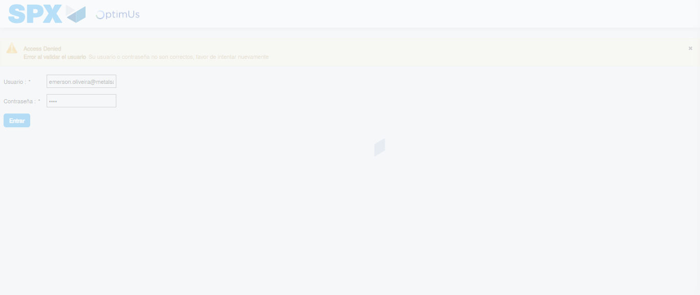Image file-name: QC_Testing-tc006_SPX_Dev5_Crear_Requisicion_Spot_Tipo_Cobro_Proyect_Urgent-1787008714317

Step 2 - Select to UEN and Access to Spot Buy Requisitions : UEN Correctly selected and Correct access
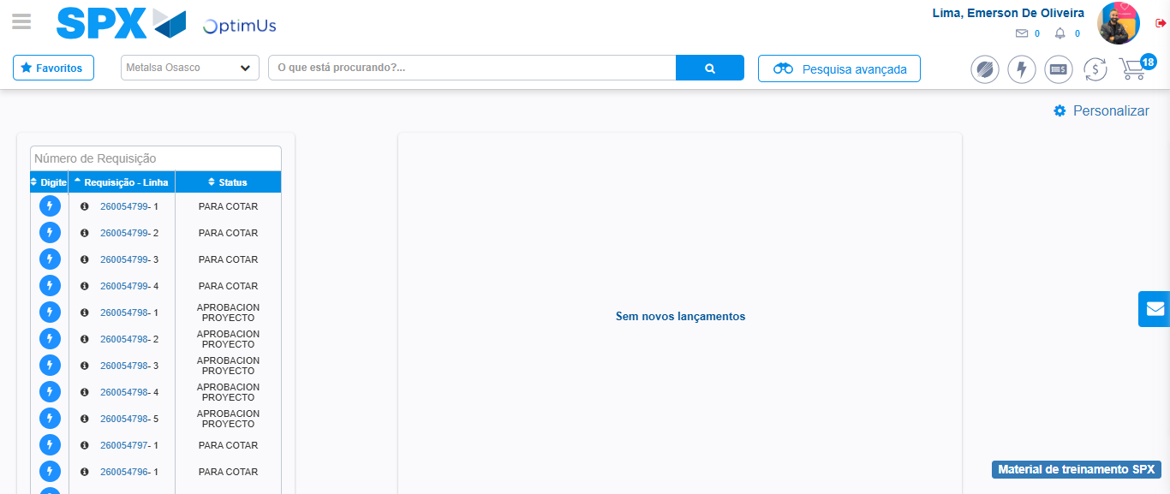Image file-name: QC_Testing-tc006_SPX_Dev5_Crear_Requisicion_Spot_Tipo_Cobro_Proyect_Urgent-1787008787297

Image file-name: QC_Testing-tc006_SPX_Dev5_Crear_Requisicion_Spot_Tipo_Cobro_Proyect_Urgent-1787008789912

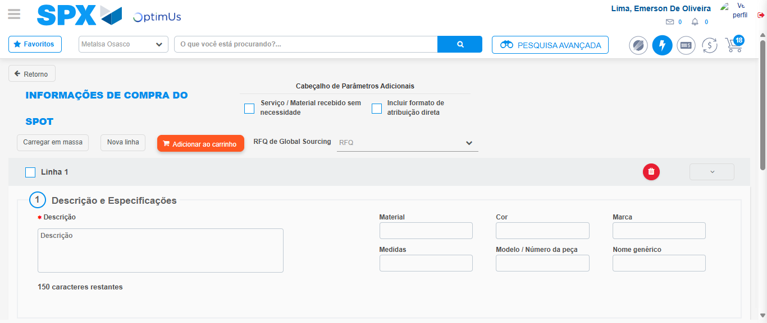Image file-name: QC_Testing-tc006_SPX_Dev5_Crear_Requisicion_Spot_Tipo_Cobro_Proyect_Urgent-1787008804730

Step 3 - Data Capture Spot Buy Requisition: Data captured correctly
Image file-name: QC_Testing-tc006_SPX_Dev5_Crear_Requisicion_Spot_Tipo_Cobro_Proyect_Urgent-1787008805001

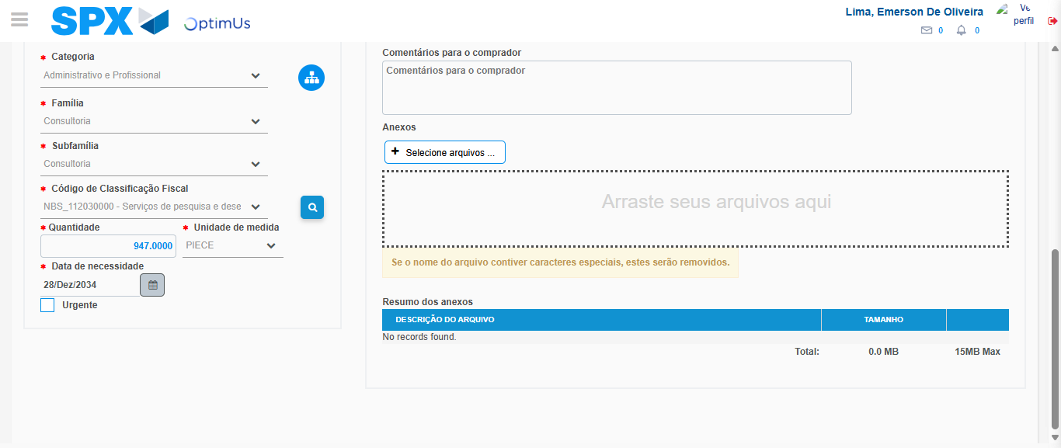Image file-name: QC_Testing-tc006_SPX_Dev5_Crear_Requisicion_Spot_Tipo_Cobro_Proyect_Urgent-1787008822094

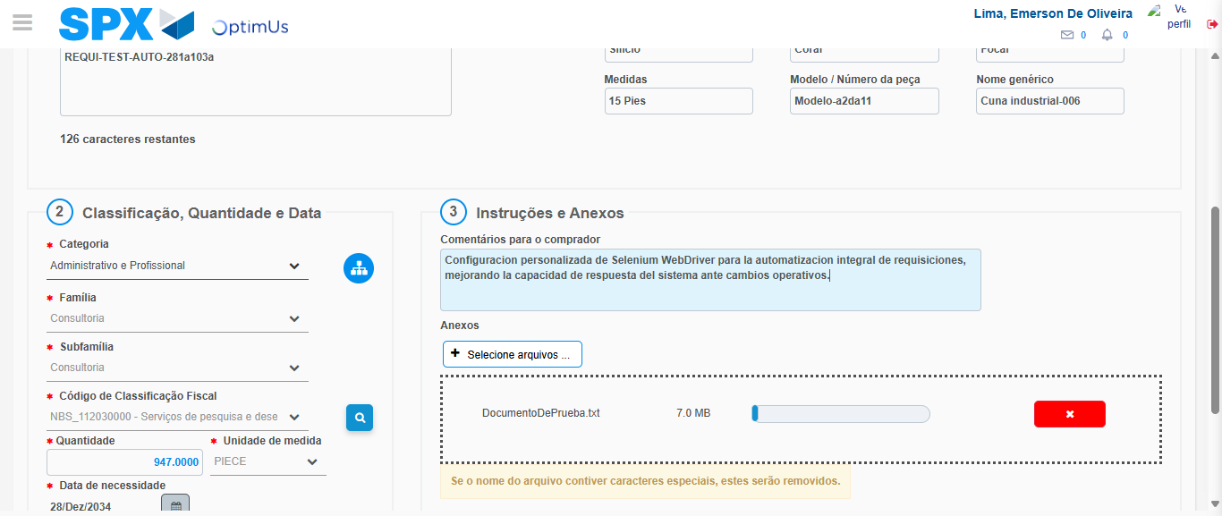Image file-name: QC_Testing-tc006_SPX_Dev5_Crear_Requisicion_Spot_Tipo_Cobro_Proyect_Urgent-1787008823051

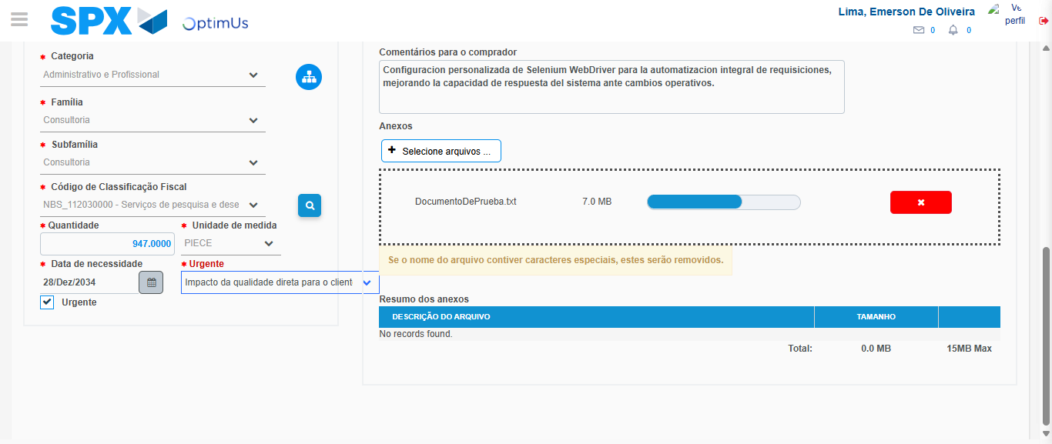Image file-name: QC_Testing-tc006_SPX_Dev5_Crear_Requisicion_Spot_Tipo_Cobro_Proyect_Urgent-1787008826888

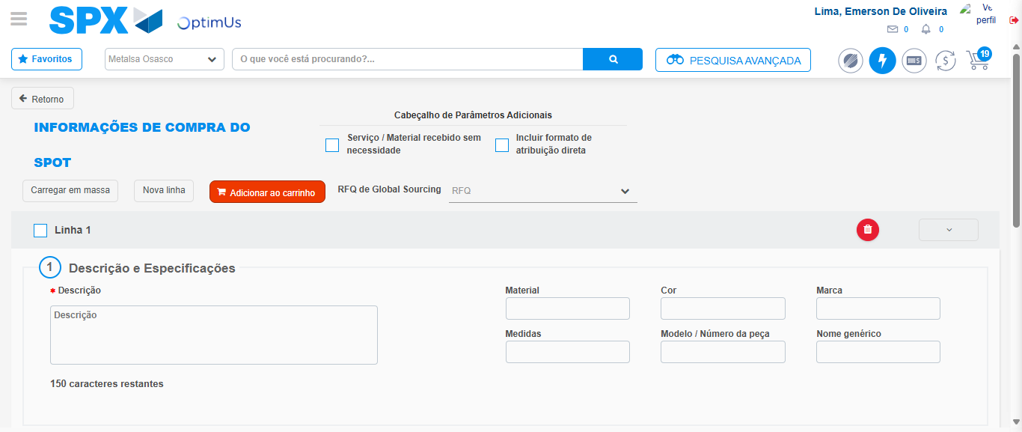Image file-name: QC_Testing-tc006_SPX_Dev5_Crear_Requisicion_Spot_Tipo_Cobro_Proyect_Urgent-1787008837577

Step 7 - Return to Main Page SPX : Return to Main Page SPX
Image file-name: QC_Testing-tc006_SPX_Dev5_Crear_Requisicion_Spot_Tipo_Cobro_Proyect_Urgent-1787008787297

Image file-name: QC_Testing-tc006_SPX_Dev5_Crear_Requisicion_Spot_Tipo_Cobro_Proyect_Urgent-1787008789912

Image file-name: QC_Testing-tc006_SPX_Dev5_Crear_Requisicion_Spot_Tipo_Cobro_Proyect_Urgent-1787008804730

Image file-name: QC_Testing-tc006_SPX_Dev5_Crear_Requisicion_Spot_Tipo_Cobro_Proyect_Urgent-1787008839870

Image file-name: QC_Testing-tc006_SPX_Dev5_Crear_Requisicion_Spot_Tipo_Cobro_Proyect_Urgent-1787008840074

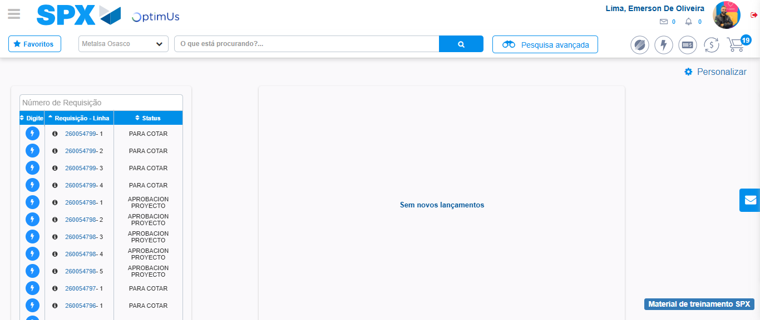Image file-name: QC_Testing-tc006_SPX_Dev5_Crear_Requisicion_Spot_Tipo_Cobro_Proyect_Urgent-1787008861220

Step 8 - Log Out : Log Out SPX
Image file-name: QC_Testing-tc006_SPX_Dev5_Crear_Requisicion_Spot_Tipo_Cobro_Proyect_Urgent-1787008861479

